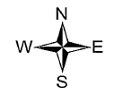
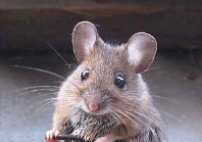


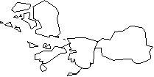
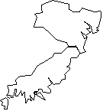
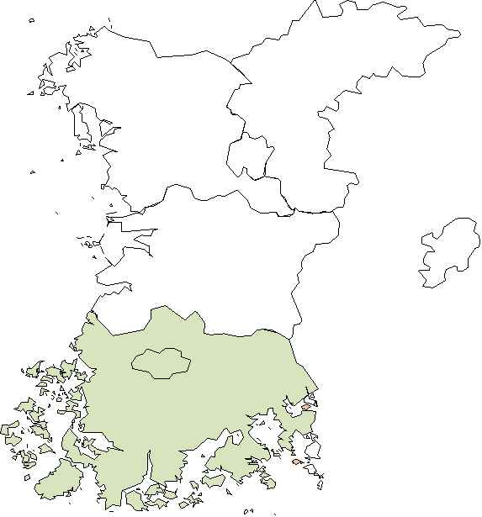
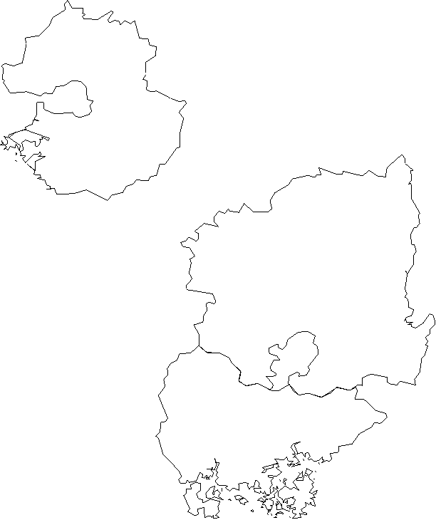
Cheorwo Yanggu Yeoncheon Hwacheon
n
Pocheon
Paju Uijeongbu Gangwon

Gyeonggi

Chungcheongbuk
Chungcheongnam

Gyeongsangbuk

Jeollabuk

Gwangju Gyeongsangnam

Jeollanam

Boseong-gun

Gwangju 47.8 km Boseong-gun

Gwangju 187 km Jeju Boseong-gun 150 km Jeju
Jeju

Geographical clustering of hantavirus in ROK
Rodent sample collection

Molecular detection

Sequencing & Phylogenetic analysis


SEROLOGICAL TEST

JJ-M18 Lung JJ-M20 Lung JJ-M21 Lung JJ-M17 Lung JJ-M22 Lung JJ-M19 Lung JJ-M55 Lung JJ-M53 Lung JJ-M54 Lung JJ-M42 Lung
68
100
45
87
78
49
10
100
26
51
99
52
66
92
94
75
100
55
76
66
100
57
97
53
69
100
78
83
96
66
47
L-segment
360bp
JN-M02 Spleen JN-M11 Spleen JN-M04 Kidney JN-M10 Spleen
JN-M19 Spleen GJ-M30 lung GJ-M06 spleen GJ-M30 spleen
Hantaan virus/Z10/China
Hantaan virus/Galkino/AA57/2002/Russia Hantaan virus/Aa14-408/Yanggu
Hantaan virus/76-118/Uijeongbu Hantaan virus/Aa14-266/Hwacheon
Hantaan virus/Aa09-948/Pocheon Hantaan virus/Aa03-161/Yeoncheon Hantaan virus/Aa14-204/Paju Hantaan virus/Aa14-362/Cheorwon
Soochong Virus/SOO-1/Inje-gun Serang virus/Rt60/2000
Seoul virus/80-39/Korea Seoul virsus/Z37/China
Seoul virus/L99/China
Dobrava-Belgrade virus/DOB/Greece Sin Nombre virus/CC107
0

Sin Nombre virus/NM H10 Andes virus/Chile-9717869
Tula virus/M5302v Muju virus/11-1/korea
Puumala virus/Umeda Puumala virus/CG1820
84 Puumala virus/Sotkamo

0.05

